**MongoDB Task**

**Database for Zen class programme :**

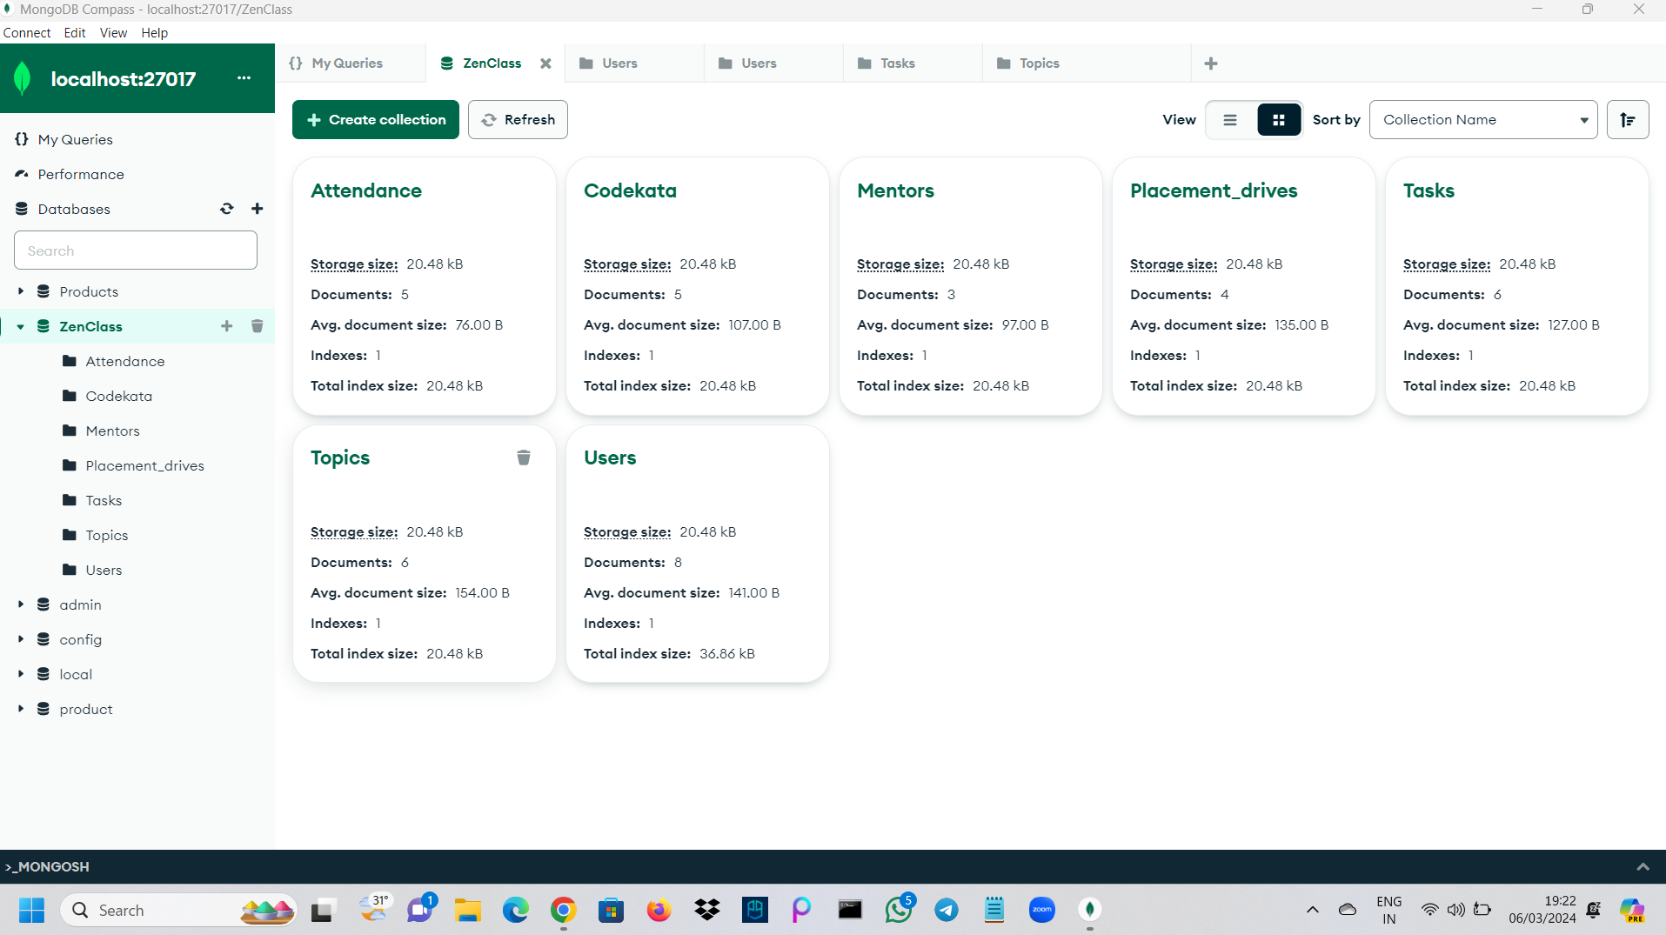

**1. Find all the topics and tasks which are thought in the month of October**

**Query :**

**db.Topics.aggregate([**

**{**

**$match: {**

**month: "October"**

**}**

**},**

**{**

**$lookup: {**

**from: "Tasks",**

**localField: "_id",**

**foreignField: "topic_id",**

**as: "tasks"**

**}**

**}**

**])**

**2. Find all the company drives which appeared between 15 oct-2020 and**

**31-oct-2020**

**Query :**

**db.Placement_drives.aggregate([**

**{**

**$match: {**

**date: {**

**$gte: ISODate("2020-10-15"),**

**$lte: ISODate("2020-10-31")**

**}**

**}**

**}**

**])**

**3. Find all the company drives and students who are appeared for the placement.**

**Query :**

**db.Placement_drives.aggregate([**

**{**

**$lookup: {**

**from: "Users",**

**localField: "appeared_students",**

**foreignField: "_id",**

**as: "appeared_students_info"**

**}**

**}**

**])**

**4. Find the number of problems solved by the user in codekata**

**Query :**

**db.Codekata.aggregate([**

**{**

**$lookup: {**

**from: "users",**

**localField: "user_id",**

**foreignField: "_id",**

**as: "user_info"**

**}**

**},**

**{**

**$unwind: "$user_info"**

**},**

**{**

**$project: {**

**_id: "$user_info._id",**

**name: "$user_info.name",**

**problems_solved: "$problems_solved"**

**}**

**}**

**])**

**5. Find all the mentors with who has the mentee's count more than 15**

**Query :**

**db.Mentors.aggregate([**

**{**

**$match: { mentee_count: { $gt: 15 } } // Filter mentors with mentee count greater than 15**

**},**

**{**

**$lookup: {**

**from: "Users",**

**localField: "user_id",**

**foreignField: "_id",**

**as: "mentor_info"**

**}**

**},**

**{**

**$project: {**

**_id: "$mentor_info._id",**

**name: "$mentor_info.name",**

**email: "$mentor_info.email",**

**mentee_count: 1**

**}**

**}**

**])**

**6. Find the number of users who are absent and task is not submitted between 15 oct-2020 and 31-oct-2020**

**Query :**

**db.Attendance.aggregate([**

**{**

**$match: {**

**date: {**

**$gte: ISODate("2020-10-15"),**

**$lte: ISODate("2020-10-31")**

**},**

**status: "absent"**

**}**

**},**

**{**

**$lookup: {**

**from: "Tasks",**

**localField: "user_id",**

**foreignField: "user_id",**

**as: "task_info"**

**}**

**},**

**{**

**$match: {**

**"task_info": { $eq: [] } // Filter users with no submitted tasks**

**}**

**},**

**{**

**$count: "total_users"**

**}**

**])**